**NATIONAL UNIVERSITY HO CHI MINH CITY**

**UNIVERSITY OF INFORMATION TECHNOLOGY**

**FACULTY OF INFORMATION SYSTEMS**

🙥**&**🙧



**PROJECT REPORT**

**E-COMMERCE SYSTEM DESIGN**

**TOPIC**

**E-COMMERCE SYSTEM DESIGN FOR DRY FRUIT BRAND GREEN HARVEST**

**Course:** EC312.O22.TMCL

**Lecturer:** Mr.Nguyen Duong Tung

**Group implementation:** Group 1

Nguyen Thi Thu Thuy 20520797

Nguyen Cam Tu 20520837

Nguyen Thanh Son 20521847

Pham Ngoc Phuong Anh 21520585

Nguyen Thi Mai Chi 21520650

Vo Pham Dang Khoa 21521005

**Ho Chi Minh City, May 2024**

# ACKNOWLEDGMENTS

On behalf of the group, we would like to express our deepest gratitude to Mr. Nguyen Duong Tung for his time, knowledge, and dedication to our project for the E-commerce System Design course (EC312.O22.TMCL). It has truly been a meaningful and enriching learning and experiential journey.

The project execution process has provided us with many valuable lessons on how to build a successful e-commerce system. We have learned how to analyze, design, and implement system features, as well as how to operate and manage the system effectively. This will be very helpful for us in the future when working in the field of information technology and e-commerce.

We would also like to express our sincere gratitude to you for your enthusiastic guidance, answering our questions, and providing valuable advice to help us complete the project successfully. Your support and expertise were instrumental in helping us overcome challenges and achieve our goals.

Once again, we would like to express our deepest gratitude to Mr. Nguyen Duong Tung and wish him good health, happiness, and success in all aspects of his life.

# INSTRUCTOR’S COMMENTS

……………………………………………………………………………………………..

……………………………………………………………………………………………..

……………………………………………………………………………………………..

……………………………………………………………………………………………..

……………………………………………………………………………………………..

……………………………………………………………………………………………..

……………………………………………………………………………………………..

……………………………………………………………………………………………..

……………………………………………………………………………………………..

……………………………………………………………………………………………..

……………………………………………………………………………………………..

……………………………………………………………………………………………..

……………………………………………………………………………………………..

……………………………………………………………………………………………..

……………………………………………………………………………………………..

……………………………………………………………………………………………..

……………………………………………………………………………………………..

……………………………………………………………………………………………..

……………………………………………………………………………………………..

……………………………………………………………………………………………..

……………………………………………………………………………………………..

……………………………………………………………………………………………..

……………………………………………………………………………………………..

……………………………………………………………………………………………..

……………………………………………………………………………………………..

……………………………………………………………………………………………..

……………………………………………………………………………………………..

……………………………………………………………………………………………..

……………………………………………………………………………………………..

……………………………………………………………………………………………..

# TABLE OF CONTENT

ACKNOWLEDGMENTS 2

INSTRUCTOR’S COMMENTS 3

TABLE OF CONTENT 4

LIST OF FIGURES 6

LIST OF TABLES 7

CONTENTS 9

CHƯƠNG 1: INTRODUCTION 9

1.1. Project Overview: 9

1.2. Project Rationale: 9

1.3. Products and Services: 10

1.4. Market Research: 10

1.5. Business Analysis: 17

1.6. Sources of supply: 19

1.7. Supply chain model: 22

1.8. Revenue Model: 23

CHƯƠNG 2: BUSINESS MODEL CANVAS (BMC) 25

CHƯƠNG 3: BUSINESS PROCESS 30

3.1. Organizational Structure 30

3.2. Core Business Processes 30

CHƯƠNG 4: BUSINESS STRATEGY 31

CHƯƠNG 5: SYSTEM ANALYSIS AND DESIGN 34

5.1. Software requirements specification (SRS) 34

5.2. Functional and non-functional requirements 64

CHƯƠNG 6: IMPLEMENTATION AND EXECUTION 64

6.1. Deployment Description 64

6.2. Core System Functionalities 64

6.3. Integration of APIs, Web Crawlers, and Web Automation 64

6.4. Evaluation of Achieved Results 64

CHƯƠNG 7: CONCLUSION AND DEVELOPMENT DIRECTIONS 64

7.1. Summary of Achieved Results 64

7.2. Limitations and Challenges 64

7.3. Future Development Directions 64

REFERENCES 65

# LIST OF FIGURES

Figure 1‑1.Supply chain model 21

Figure 1‑2. 21

Figure 2‑1. Business model canvas 24

Figure 5‑1. Context Diagram 33

Figure 5‑2. Use case diagram 34

Figure 5‑3. Usecase Diagram Customer Manage Cart 42

Figure 5‑4. Usecase Diagram Customer Manage Profile 44

Figure 5‑5. Usecase Diagram Customer Ordering and payment 45

Figure 5‑6. Activity Diagram - View Order Details 48

Figure 5‑7. Activity Diagram - Cart Management 49

Figure 5‑8. Activity Diagram - Add Product to Cart 50

Figure 5‑9. Activity Diagram - Pool 51

Figure 5‑10. Activity view product 51

Figure 5‑11. Activity Diagram - Login 52

Figure 5‑12. Activity Diagram - Register 52

Figure 5‑13. Sequence Product management Back Function 53

Figure 5‑14. Sequence Product management Insert Function 53

Figure 5‑15. Sequence Product management delete Function. 54

Figure 5‑16. Sequence Product management Update Function 55

Figure 5‑17. Sequence product management. 56

Figure 5‑18. Sequence Staff management Back Function 57

Figure 5‑19. Sequence Staff management delete function 57

Figure 5‑20. Sequence Staff management Update function 58

Figure 5‑21. Sequence Staff management. 59

Figure 5‑22. Sequence Customer Management Back function 60

Figure 5‑23.Sequence Customer Management delete Function 60

Figure 5‑24.Sequence Customer Management Update Function 61

Figure 5‑25. Sequence Customer management 62

# LIST OF TABLES

Table 1‑1. Export Value and Share in Total Export Value of Fruits in 2015 for Some Commodities (Source: UN Comtrade, 2017) 12

Table 1‑2. SWOT table comparing Vinamit with L'ang Farm 17

Table 5‑1. Detailed Specification Table Customer Login 36

Table 5‑2. Detailed Specification Table Customer LogOut 36

Table 5‑3. Detailed Specification Table Customer Explore Product 37

Table 5‑4. Detailed Specification Table Customer Manage Cart 37

Table 5‑5. Detailed Specification Table Customer Manage Profile 37

Table 5‑6. Detailed Specification Table Customer Review Product 38

Table 5‑7. Detailed Specification Table Customer Ordering and Payment 38

Table 5‑8. Detailed Specification Table Administrator LogIn 39

Table 5‑9. Detailed Specification Table Administrator LogOut 39

Table 5‑10. Detailed Specification Table Administrator Staff Management 39

Table 5‑11. Detailed Specification Table Administrator Shipping Management 40

Table 5‑12. Detailed Specification Table Administrator Warehouse Management 40

Table 5‑13. Detailed Specification Table Administrator Create Staff Account 41

Table 5‑14. Detailed Specification Table Staff LogIn 41

Table 5‑15. Detailed Specification Table Staff LogOut 41

Table 5‑16. Detailed Specification Table Staff Promotion Management 42

Table 5‑17. Detailed Specification Table Staff Product Management 42

Table 5‑18. Detailed Specification Table Staff Customer Management 42

Table 5‑19. Detailed Specification Table Customer Manage Cart 43

Table 5‑20. Detailed Specification Table Customer Add Product 44

Table 5‑21. Detailed Specification Table Customer Update Cart 44

Table 5‑22. Detailed Specification Table Customer Delete Product 44

Table 5‑23. Detailed Specification Table Customer Manage Profile 45

Table 5‑24. Detailed Specification Table Customer Update Profile 46

Table 5‑25. Detailed Specification Table Customer View Payment History 46

Table 5‑26. Detailed Specification Table Customer Ordering and Payment 47

Table 5‑27. Detailed Specification Table Customer Order Tracking 47

Table 5‑28. Detailed Specification Table Customer Cash on Delivery 48

Table 5‑29. Detailed Specification Table Customer Bank Payment 48

# CONTENTS

## INTRODUCTION

### Project Overview:

Green Harvest is a young, dynamic, passionate, and creative company. We are currently focusing on developing the dried fruit market. This is a newly emerging market with great potential. Identifying the right market needs will help the Green Harvest dried fruit brand grow rapidly. Green Harvest's goal is to promote Vietnamese agricultural products to the world, build the Green Harvest dried fruit brand chain as the most famous dried fruit brand in Vietnam. In addition, we also have a noble mission of increasing the value of Vietnamese agricultural products, creating more income for farmers, and meeting market demand.

### Project Rationale:

The demand for natural food products, especially fruits, is increasing rapidly. However, transporting and preserving these perishable items is extremely challenging and expensive. For instance, China's closure of its northern small border gates to prevent the spread of COVID-19 has left hundreds to thousands of containers stranded, mostly filled with perishable fruits. This has resulted in hundreds of tons of mangoes, dragon fruits, and other fruits going unsold due to spoilage. Even if the fruits can be preserved for sale to small traders, the costs of freezing, labor, and fuel increase significantly. Moreover, fruit prices are constantly fluctuating and unstable. Every year, farmers face the situation of bumper harvests and low prices. In addition to the measures taken by government agencies, there is a need for an alternative market and product for agricultural products in general and fruits in particular to elevate the value of these commodities. The core issue at present is how to convert fruits into products that have a long shelf life, high value, and are easy to transport. The answer lies in dried fruits, which are currently gaining popularity. The group will present the development of the dried fruit market and the establishment of a dried fruit brand in this project for the E-commerce System Design course.

### Products and Services:

* Products:
* Sun-dried cherry tomatoes
* Coffee beans
* Dried guava
* Matcha powder
* Dried pomelo peel
* Sun-dried sweet potatoes
* Additional Services:
* Gift wrapping with cards for customers who want to give gifts
* Create pre-made or custom combos with optional greeting cards
* Implement promotional programs such as gift vouchers

### Market Research:

#### 1.4.1. Current Situation:

* The demand for fruits is increasing rapidly, especially as healthy lifestyles are being promoted more widely. Fresh fruits are often seasonal, although some off-season varieties are available, they are usually quite expensive. This means that some fruits are not always available. On the other hand, dried fruits can retain the original flavor of the fruit, have a longer shelf life, and are usually priced reasonably. While fresh fruits are a daily snack because of their juiciness and freshness, dried fruits have their own unique sweet and savory flavors. Along with their convenience, dried fruits are gradually becoming a popular snack.
* The demand for dried fruits is also increasing. In the past, the demand for dried fruits was often concentrated on holidays and Tet, but now the demand for dried fruits as a daily snack is becoming more and more common and regular. In fact, it shows that the demand for this item from users is increasing. In fact, many supermarkets have decided to import dried fruits from Korea, Japan, Australia, and Thailand to diversify their product range at prices that are many times higher than domestic food. This creates opportunities in a market with great potential for development.
* According to a survey, Korean and Japanese dried persimmons and soft persimmons are sold at imported fruit stores in Ho Chi Minh City for nearly VND 2 million per box of 36 fruits. Similarly, whole dried Australian grapes are also sold for VND 2.5 million to VND 4 million per box of 5kg to 7kg. Or dried cherries from the US are also sold for VND 700,000 - 900,000 per kg. Meanwhile, as a country with a tropical monsoon climate, Vietnam always has an abundant supply of fruits to provide to users. Domestic Vietnamese dried goods are only priced from a few hundred thousand to nearly VND 1 million per kg depending on the type, even though they have comparable quality. In addition to popular dried fruits such as jackfruit, banana, tamarind, bitter melon, ... the domestic market also has many new types of dried fruits such as dried durian, dried coconut, dried mango, Da Lat crispy persimmons, chestnuts, almonds, macca nuts, walnuts, ... with much more reasonable prices.
* According to research from EVFTA, in 2015, dried fruits accounted for 10% of the total value of exported fruits, ranking second in the group of exported fruit products. From this, we can see that the demand for exporting dried fruits is very large and promising. One of the major difficulties of exporting fruits is the matter of preservation. And with dried fruits, when we know how to apply modern processing techniques, preservation is no longer a problem.

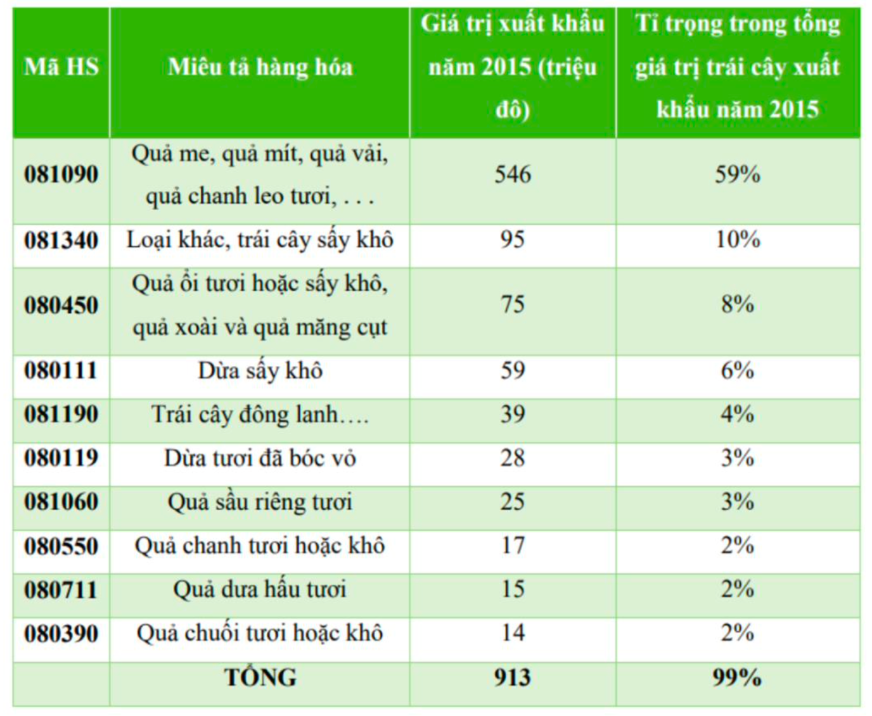

Table 1‑1. Export Value and Share in Total Export Value of Fruits in 2015 for Some Commodities (Source: UN Comtrade, 2017)

* The figures above demonstrate the immense potential of both domestic and imported dried fruits.
* Due to their delectable taste and convenience, dried fruits have become one of the best-selling food items today. And the places to find them are no longer limited to supermarkets and tourist destinations but have now expanded to even small grocery stores. Therefore, the dried fruit and nut business is a smart and sound choice for small businesses today.

#### 1.4.2. Competitors:

**List of competitors in the South:**

* Nam Huy Dong Thap Co., Ltd.
* Viet Chuoi facility
* Vietnam Organic Coffee Bean Co., Ltd.
* TL Trading & Services Co., Ltd.
* L'ang Farm Co., Ltd.
* Vinamit Co., Ltd.

**List of competitors in the North:**

* Bac Nam Trading Co., Ltd.
* Vietnam Dried Mango Store
* Haiyan Investment Joint Stock Company

**List of competitors in the Central region:**

* ASIA Fruit Store - Da Nang

**Analysis of some competitors:**

**A. L’ang Farm:**

* L'angfarm is a brand of Quang Thai Co., Ltd., established in 2002 in Da Lat City. Currently, L'angfarm is a leading Da Lat specialty brand, providing high-quality, safe, reliable, affordable, eye-catching, and satisfying processed agricultural products such as: artichoke tea, specialty cakes and jams, coffee, seeds, essences, herbs, dried meat, hot brew tea, tea bags, soft dried fruits, crispy dried fruits, matcha green tea powder, sencha flower tea, ...
* Langfarm Store is a chain of retail stores specializing in Da Lat specialties with the aim of bringing the safest, highest quality and most beautiful Da Lat specialties to customers; Circulate goods according to standards with the best controlled prices; Provide the most perfect shopping experience; Listen to customer feedback carefully; Create the most satisfied after-sales service base. Currently, L'angfarm Store has over 35 stores in Da Lat City, Ho Chi Minh City, Nha Trang, Da Nang, Vung Tau and will continue to expand nationwide.
* Quality products, safe and hygienic, agricultural origin, beautiful packaging, affordable prices, and satisfactory after-sales service. These are both outstanding features of the L'angfarm Store system, a commitment of the business to customers, and a compass for all the efforts and endeavors of L'angfarm in the future.
* Currently, the L'angfarm retail store system, in addition to being popular in Da Lat, is also present in major cities across the country such as Ho Chi Minh City, Hanoi, Da Nang, Nha Trang, Vung Tau.
* Products/services: 17.000 VNĐ - 417.000 VNĐ
  + Dried fruits
  + Roasted nuts
  + Basa fish skin
  + Fruit chocolate
  + Candles
  + Fish skin
  + Dried fish
  + Matcha green tea powder, beetroot powder
  + Teas
  + Gift sets

**B. Vinamit:**

* Vinamit is proud to be one of the units that owns the leading post-harvest agricultural food processing technology in Vietnam. For many years, Vinamit has achieved achievements and food safety and hygiene certificates in Vietnam and around the world such as:
  + High Quality Vietnamese Goods Certificate
  + HACCP certificate
  + HALAL Food Certificate
  + KOSHER certificate
  + ISO 9001:2008 international standard
  + FDA certificate
  + USDA Organic Certificate
  + EU Organic Certificate
* With the vision of elevating the value of Vietnamese agricultural products to the world, Vinamit is constantly striving to take Vietnamese agriculture and agricultural products to a new level. Vinamit's mission is to bring consumers life flavors from nature through their products. In addition, helping farmers, and finding outlets for post-harvest products, encouraging farmers to cultivate is also an important mission of Vinamit.
* Vinamit's products are now present in all large and small stores and chains of supermarkets and convenience stores across the country. In addition, Vinamit's dried fruit products have been exported and warmly received in many countries around the world such as China, Thailand, Japan, Singapore... and with other demanding but potential markets such as the US, Europe, and the Euro Community.
* Products/services: 12 – 785.000 VNĐ
  + Organic vegetables
  + Freeze-dried products
  + Soft dried fruits
  + Vacuum-dried fruits
  + Nuts
  + Tea powder, coffee powder, candy

|  |  |  |
| --- | --- | --- |
| **Company** | **Vinamit** | **L’ang Farm** |
| **Strengths** | Leading dried food manufacturer in Vietnam * Over 20 years of experience and remarkable growth in recent years  Ample capital for IT development  Recognizes the importance of IT and has a long-term plan for IT application  Vinamit's IT investment projects have basically met IT needs, well serving business operations  Vinamit's IT team quickly adapts to the modern environment and new technologies to effectively serve their work  The company has begun to implement a professional IT operation model (General Management Company; outsourcing some IT services) | High aesthetic and environmentally friendly packaging  Unique products  Japanese infrastructure and production processes meet ISO 9001 and HACCP standards  Experienced staff and foreign consultants |
| **Weaknesses** | The company has not focused on synchronized investment between blocks. This leads to the situation that the application has been effective in each block but has not been effective when linking between blocks.  The implementation time of IT projects is still long. Therefore, some projects have not met the production and business needs in time.  After a period of operation, the quality of some application systems has deteriorated:   * Not focusing on training and retraining application operators; * Not regularly reviewing and improving operating procedures; * Not focusing on maintaining and ensuring operational efficiency after the system is put into operations; * No regular software updates.   In addition, the company has not yet been able to invest in some effective software to increase the efficiency of business operations. | No experience in international business.  Limited capital scale.  Products are not essential. |
| **Opportunities** | Vinamit is developing rapidly both domestically and internationally. Vinamit's products are suitable and very popular in the foreign market.  The rapid and strong development trend of IT and e-commerce allows businesses to have many choices and additional tools to implement their business ideas. | The agricultural product market is Vietnam's strength.  Potential to lead in the field of processed agricultural product export in Vietnam. |
| **Threats** | Vinamit's products are quite popular and well-known, so the ability of consumers to access the Internet to find product information is quite low.  In Vietnam, the level and legal system of e-commerce are still incomplete. IT enterprises providing IT services are not of high quality. These are difficulties for Vinamit's IT development. | Strict requirements on product quality and origin.  Direct competition with domestic and international brands |

Table 1‑2. SWOT table comparing Vinamit with L'ang Farm

### Business Analysis:

* S (Strengths):
  + Product quality: Green Harvest is providing clean agricultural products that have the potential to attract customers who are concerned about health and food safety.
  + Good relationships with the farming community: If the project has good relationships with the farming community or has the ability to partner with them, this can help ensure a reliable supply of agricultural products and support the local community.
  + Stable supply: Having a long-term and reliable supply of agricultural products helps ensure a fresh and clean source of raw materials for the products.
  + Brand image: The products and Green Harvest have an eye-catching design that is easy to recognize the brand. The website has an impressive and easy-to-use interface.
  + Exclusive drying technology: Dried using the latest technology, certified by...
  + Efficient delivery and distribution: Have an efficient delivery and distribution process, helping to meet customer needs quickly and reliably.
* W (Weaknesses):
  + High production costs: Producing clean agricultural products may require meticulous care, strict production processes and quality control, leading to higher production costs than conventional agricultural products. This can reduce profits and make products expensive for customers.
  + Marketing and customer outreach challenges: Reaching and marketing clean agricultural products can sometimes be more difficult due to the need to introduce and convince customers of the benefits of clean agricultural products.
  + Limitations on production scale: The project may face limitations in production scale, which may affect its ability to meet market demand and compete with larger competitors.
  + Variable raw material quality: The project may have difficulty controlling the quality of raw materials from the supply source.
* O (Opportunities):
  + Growing demand for clean products: Concerns about health and food safety are driving demand for clean agricultural products. The Green Harvest project can take advantage of this opportunity to increase product output and attract a large number of customers interested in clean agricultural products.
  + Government clean food programs: Some countries or regions have government-supported clean food programs. The Green Harvest project can take advantage of this opportunity to participate in these programs and receive financial support or preferential regulations.
* T (Threats):
  + Strong competition: The clean agricultural products market has strong competition from other players. This competition can put pressure on prices and profits.
  + Health and food safety issues: If there are any health or food safety incidents, this can damage the project's reputation and cause customers to lose confidence.
  + Price competition: is a significant risk for the Green Harvest project, especially as clean agricultural products are typically more expensive than conventional products.

### Sources of supply:

**Some places where you can buy large quantities of fruit near Ho Chi Minh City:**

**A. Wholesale fruit market in Ho Chi Minh City - Thu Duc City**

* Location: Thu Duc wholesale fruit market is considered the largest supplier of agricultural products, food and fruits in Ho Chi Minh City, located on Xuyen A road, Hiep Binh Phuoc ward, Thu Duc district, right at the eastern gateway of Ho Chi Minh City to the provinces, the Central region, the Eastern region and the Central Highlands.
* A variety of fruits are available at the market: rambutans, grapefruit, oranges, dragon fruit, durian, mangosteen, oranges, grapes, guava, plums, etc.
* Buying and selling here continuously day and night is the most convenient and stable source of supply.

**B. Cai Rang floating market (Can Tho)**

* Location: Cai Rang floating market is a market on the river, right under Cai Rang bridge, Cai Rang district, near the center of Can Tho city. This is also a wholesale market for fruits and vegetables that cannot be missed by fruit shop owners.
* The market mainly trades in fruits from the Southwest region, in addition to other food and agricultural products.
* The types of fruits you can buy wholesale include: durian, longan, cherry, papaya, coconut, grapefruit, rambutan, watermelon, pineapple, sapodilla...

**C. An Huu - Cai Be floating market (Tien Giang)**

* Location: Located along Tan Phong islet on the Tien River, Cai Be town, bordering 3 provinces of Vinh Long, Tien Giang and Ben Tre, so buying and selling is very busy. The market is the gathering place of all kinds of fruits in the Mekong Delta region.
* The types of fruits at this wholesale market are quite diverse, especially the specialized fruits of Tien Giang such as green-skinned grapefruit, Bac Moc chapo, Lo Ren milk fruit, Tan Lap pineapple, Cai Be oranges, sành oranges...

**D. Cao Lanh wholesale fruit market (Dong Thap)**

* Location: Located at Ap 2, My Hiep commune, Cao Lanh district, Dong Thap province.
* Daily consumption: 120 - 150 tons, the most consumed is the Hoa Loc mango variety, which is now widely planted in Cao Lanh (56.2 ha).
* Rich fruit sources: In addition to the famous Hoa Loc mango, which is sold wholesale in hundreds of tons to all over the place, other fruits such as durian, coconut, grapefruit, milk fruit, pineapple, banana... also have a high consumption.

**Some stores that can supply:**

**A. Clean fruit store 141**

* Address: 139 - 141 - 143 An Dương Vương, Ward 8, District 5, Ho Chi Minh City. 242 - 244 Le Thanh Ton, Ben Thanh Ward, District 1, Ho Chi Minh City. 131 -133 Nguyen Tri Phuong, Ward 8, District 5, Ho Chi Minh City.

**B. Cau Dat Farm Showroom**

* Address: 313 Nguyen Thi Thap, Tan Phu Ward, District 7, Ho Chi Minh City.
* Specialized in selling: Vegetables, fresh flowers, coffee & tea from Cau Dat Farm - a farm from Da Lat.

**C. 3 clean food store**

* Address: 24 Nguyen Truong To, Ward 12, District 4, Ho Chi Minh City. 246 Nguyen Dinh Chieu, Ward 6, District 3, Ho Chi Minh City. 124 Tran Nao, An Loi Dong Ward, District 2, Ho Chi Minh City.

**D. Greeny House**

* Address: 1B Suong Nguyet Anh, Ben Thanh Ward, District 1, Ho Chi Minh City. Sunrise City, North Tower lot X1-17, No. 27 Nguyen Huu Tho, Tan Hung Ward, District 7, Ho Chi Minh City.

**Some drying partners:**

* MacTech Company: C68/2 Street No. 2, Ap My Hoa 2, Thoi Dong commune, Hoc Mon district, Ho Chi Minh City.
* TechMart Company: 10 Ap Hau Lan, Ba Diem, Hoc Mon, Ho Chi Minh City.
* Vietnam Green Technology Company: 79 Truong Dinh, Ben Thanh Ward, District 1, Ho Chi Minh City.
* Hoang Gia Electrical Appliances Company: No. 14C TX 13 Street, Group 9, Ward 1, Thanh Xuan Ward, District 12, Ho Chi Minh City.
* LAS Vietnam Co., Ltd.: 25 Street No. 7, Tam Binh Ward, Thu Duc City, Ho Chi Minh City.

**Packaging partners:**

* Nam Tien Packaging Trading and Manufacturing Joint Stock Company: 565 Tan Ky Tan Quy, Tan Quy Ward, Tan Phu District, Ho Chi Minh City.
* Dat Thuan Packaging Import-Export Trading and Manufacturing Co., Ltd.: 131/16 Tay Lan Street, Binh Tri Dong A Ward, Binh Tan District, Ho Chi Minh City.
* Hong Phuc One Member Printing Co., Ltd.: 3C-3D-3E Street 14, KP. 12, Binh Hung Hoa A Ward, Binh Tan District, Ho Chi Minh City.
* NHK Printing and Packaging Joint Stock Company: 61B1 Nguyen Van Bua, Ap 5, Xuan Thoi Son Commune, Hoc Mon District, Ho Chi Minh City.
* Dong Nhat Tien Trading and Service Production Co., Ltd.: 286/19 Chien Luoc Street, Ward 3, Binh Tri Dong A Ward, Binh Tan District, Ho Chi Minh City.

In addition, the group will cooperate with other shipping companies to coordinate and transport goods to customers as well as import goods from suppliers and between partners in order to bring the fastest, most efficient and most satisfactory experience to customers.

### Supply chain model:

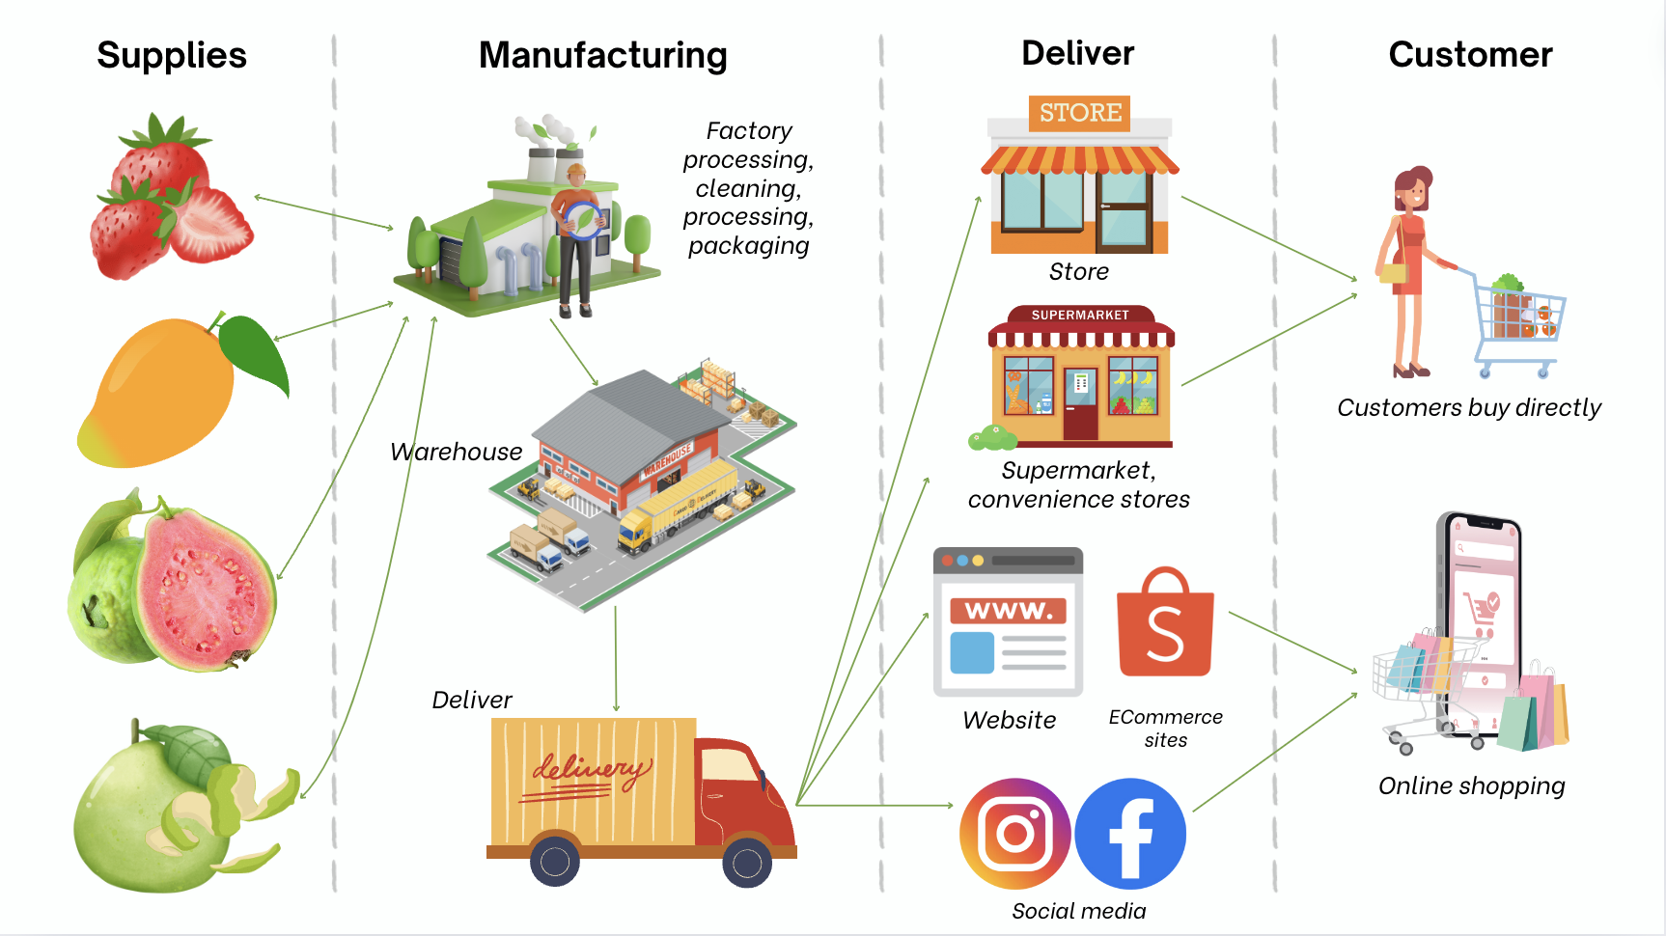

Figure 1‑1.Supply chain model

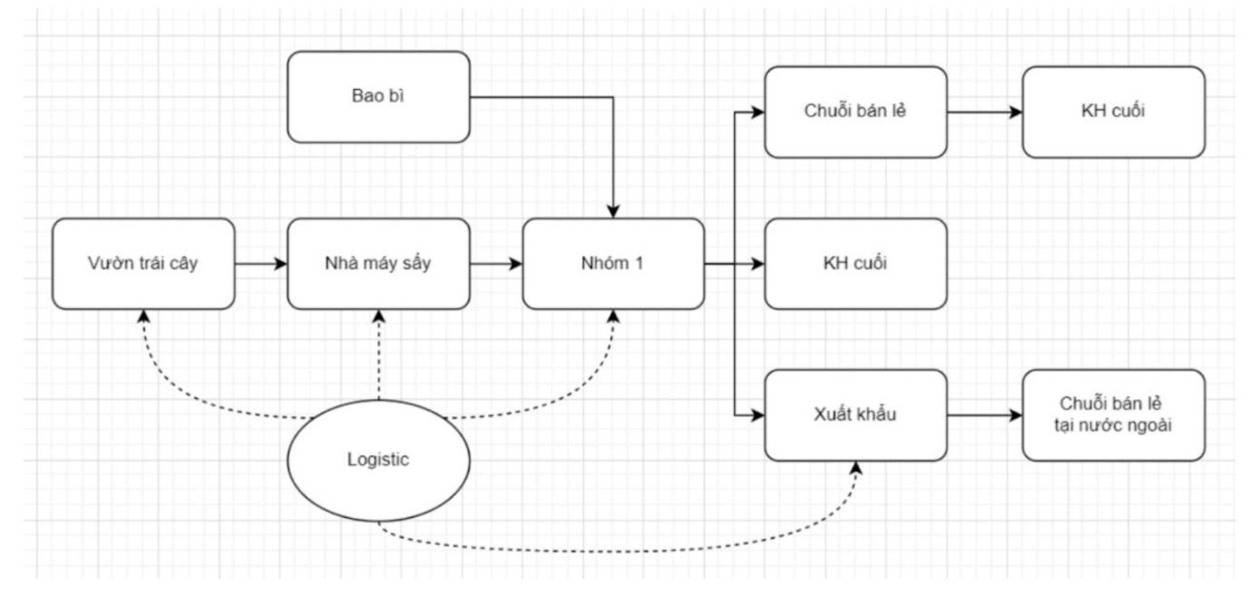

Figure 1‑2.

‑

### Revenue Model:

A revenue model is a framework that describes how a business generates revenue. It outlines the sources of income, pricing strategies, and customer segments that contribute to the overall profitability of the company.

* Common Revenue Models in E-commerce: While a wide range of revenue models exist in e-commerce, the most fundamental ones include:
  + Advertising-Supported Revenue Model: Businesses generate revenue by displaying ads on their platforms or websites. Advertisers pay based on impressions, clicks, or conversions.
  + Subscription Revenue Model: Customers pay a recurring fee to access a service or product on a regular basis. This model is common for streaming services, software subscriptions, and digital content providers.
  + Fees Revenue Model: Businesses charge fees for services they provide, such as transaction fees, shipping fees, or membership fees. This model is often used by payment processors, e-commerce marketplaces, and online booking platforms.
  + Sales Revenue Model: Businesses generate revenue by selling products directly to customers. This is the traditional model used by retailers, both online and offline.
  + Affiliate Revenue Model: Businesses earn commissions by referring customers to other businesses. This model is often used by bloggers, influencers, and content creators who promote products or services to their audience.
* Green Harvest adopts a **Sales Revenue Model**, where the primary source of income comes from direct sales of its dried fruit products. Customers place orders for the dried fruits online or through the company's retail stores. The company procures fresh fruits, processes them into dried fruits, packages them with branding labels, and delivers them to customers. This model allows Green Harvest to control the entire supply chain, ensuring product quality and customer satisfaction.
* **Key Aspects of Green Harvest's Sales Revenue Model:**
  + Product Quality: Green Harvest emphasizes the quality of its dried fruits, using fresh, locally sourced ingredients and employing rigorous processing techniques.
  + Branding and Packaging: The company invests in strong branding and attractive packaging to differentiate its products and enhance customer appeal.
  + Efficient Order Processing and Delivery: Green Harvest streamlines order processing and delivery to ensure timely fulfillment and customer satisfaction.
  + Direct Customer Engagement: The company engages directly with customers through its website, retail stores, and social media channels, fostering customer loyalty and repeat purchases.
* By effectively implementing this Sales Revenue Model, Green Harvest aims to generate sustainable revenue, achieve profitability, and establish itself as a leading provider of high-quality dried fruit products.

## BUSINESS MODEL CANVAS (BMC)

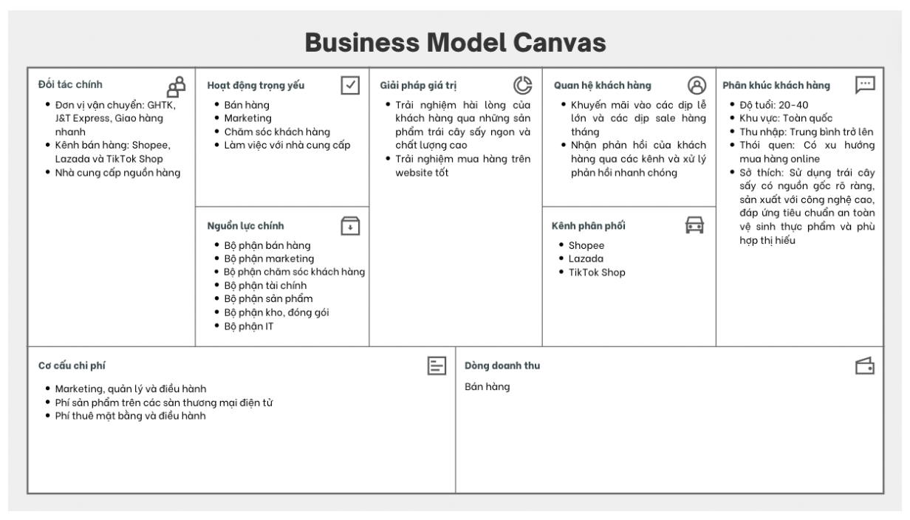

Figure 2‑1. Business model canvas

‑

* Competitive Advantages:
* Variety of fruits and agricultural products: Green Harvest offers a wide range of seasonal fruits and agricultural products, catering to diverse customer preferences.
* High production capacity: The company's ability to select the best partners ensures access to the most advanced technologies, resulting in products of the highest quality.
* Abundant supply from orchards: Green Harvest has a steady supply of fresh fruits from its network of orchards, ensuring product availability and freshness.
* Diverse sales channels: The company utilizes various sales channels, including Facebook, its website, and other online platforms, making it easy for customers to find and purchase products.
* Key Partners:
* Suppliers: Green Harvest partners with reputable fruit wholesalers in Vietnam to secure a reliable supply of high-quality fruits.
* Logistics providers: The company collaborates with trusted logistics partners like Giao Hang Tiết Kiệm, J&T Express, and Giao Hang Nhanh to ensure efficient and timely product delivery.
* Sales channels: Green Harvest leverages popular e-commerce platforms like Shopee, Lazada, and Tiktok Shop to expand its reach and connect with a wider customer base.
* Key Resources:
* Product distribution: Green Harvest primarily distributes its products through social media platforms like Facebook, e-commerce marketplaces like Shopee, and its own website.
* Customer relationships: The company focuses on building strong relationships with its customer base, particularly its loyal customers who account for 35% of total sales.
* Customer Relationships:
* **Customer attraction and retention strategies:** Green Harvest employs various strategies to attract and retain customers:
  + **Regular feedback collection:** The company actively gathers customer feedback to understand their needs and preferences and continuously improve its products and services.
  + **Frequent promotions:** Green Harvest offers attractive promotions during major holidays and monthly sales events, such as 5/5 and 6/6, to drive customer engagement and sales.
* Customer Segments:
  + Students: This segment comprises students who seek healthy snacks or gifts for friends. Considering their budget constraints, Green Harvest offers smaller, more affordable packages of dried fruits.
  + Office workers: This segment has greater spending power and higher expectations. Green Harvest caters to their needs by offering premium dried fruit products with an emphasis on health benefits and convenience, such as individual serving packages and resealable containers.
  + Gift buyers: This segment prioritizes product quality and presentation. Green Harvest meets their expectations by offering high-quality dried fruits in elegant packaging with optional gift delivery and personalized messages.
* Value Propositions:
* Health-conscious products: Green Harvest prioritizes the health and well-being of its customers by producing high-quality dried fruits without artificial additives or preservatives.
* Support for local farmers: The company's operations contribute to the economic well-being of Vietnamese farmers by providing a stable market for their produce.
* Environmentally friendly packaging: Green Harvest demonstrates its commitment to sustainability by using eco-friendly packaging materials.
* Key Activities:
* Establishing social media sales channels: Green Harvest actively promotes its products on social media platforms like Facebook and Tiktok to reach a wider audience.
* Setting up e-commerce storefronts: The company expands its online presence by establishing storefronts on popular e-commerce platforms like Shopee and Lazada.
* Managing sales operations across channels: Green Harvest effectively manages orders, inventory, and customer interactions across all its sales channels.
* Developing and implementing marketing campaigns: The company creates engaging marketing campaigns to promote its products and attract new customers.
* Handling online sales transactions: Green Harvest efficiently processes online orders, ensuring timely payments and secure transactions.
* Providing online customer support: The company offers responsive customer support through online channels to address customer inquiries and concerns.
* Managing relationships with partners and suppliers: Green Harvest maintains strong partnerships with its suppliers and logistics providers to ensure a seamless supply chain and efficient product delivery.
* Value Propositions:
* **Customer satisfaction and delight:** Green Harvest strives to deliver exceptional customer experiences by offering high-quality dried fruit products at reasonable prices and providing attentive and caring service.
* **Enhanced website experience:** The company aims to provide a seamless and user-friendly website experience, enabling customers to quickly and conveniently browse products, place orders, and access customer support resources.
* Distribution Channels:
* Social media: Green Harvest utilizes social media platforms like Facebook and Tiktok to showcase its products, engage with potential customers, and drive traffic to its website and e-commerce storefronts.
* E-commerce marketplaces: The company leverages popular e-commerce platforms like Shopee and Lazada to reach a wider audience, expand its market reach, and facilitate online transactions.
* Revenue Streams:
* Product sales: The primary source of revenue for Green Harvest is the sale of its dried fruit products to customers through its website, e-commerce storefronts, and social media channels.
* Cost Structure:
* Product research and development: Green Harvest invests in ongoing research and development to enhance its product offerings, develop new flavors, and improve product quality.
* Marketing and advertising: The company allocates resources for marketing and advertising campaigns to promote its brand, generate leads, and drive sales.
* Management and administration: Green Harvest incurs expenses related to management, administrative tasks, and general operations to support its business activities.
* E-commerce platform fees: The company pays fees to e-commerce marketplaces like Shopee and Lazada for hosting its storefronts and processing online transactions.
* Shipping and logistics: Green Harvest incurs costs associated with shipping and logistics to deliver its products to customers efficiently and timely.
* Packaging materials: The company expends resources on packaging materials to ensure the safe and secure delivery of its products while maintaining its commitment to sustainability.

## BUSINESS PROCESS

### 3.1. Organizational Structure

### 3.2. Core Business Processes

#### 3.2.1 Product Department

#### 3.2.2 Marketing Department

#### 3.2.3 Sales Department

#### 3.2.4 Technical Department

#### 3.2.5 Finance Department

## BUSINESS STRATEGY

**Short-term Goals (3 years):**

* Revenue: Sell 150 products/items ~ 3300 products/month, average product value is 65,000 VND → 2.6 billion/year.
* Profit: 850 million VND/year.
* Market: Currently serving individuals (office workers, students), in the next 3 years targeting retailers.

**Long-term Goals (6 years):**

* Revenue: Sell 300 products/items ~ 6600 products/month, average product value is 65,000 VND → 5.2 billion/year.
* Profit: 1.7 billion VND/year.
* Market: Supply goods to supermarket chains, retailers, expand to foreign markets (export) to potential markets such as China, Korea, Japan, EU.

**Product Strategy Within Business Strategy:**

***Goals to Achieve:***

* Product quality: Achieve certifications for sensory indicators (color, state, taste), physical and chemical indicators (content of substances), microbiological indicators (bacteria ratio...).
* Production cost: Find ways to reduce production costs, adjust selling prices accordingly to achieve the target profit.
* Increase sales, expand market.
* Product Strategy Content:
  + Brand:

***Product branding strategy:***

* Prioritize digital marketing
* Website chatbot: Send promotional information about items that customers have in their carts.
* Facebook search advertising (keyword bidding).
* Use Google Trends tools to find relevant keywords: avoid generic keywords with high search volume.
* Start advertising in automatic mode to experiment, find which keywords can generate the most orders at the best cost.
* Gradually optimize keywords and reduce budget:
  + Turn off keywords with high Average Cost of Sale (ACOS).
  + Use long-tail keywords that are relevant to the product and adjust the budget accordingly for each keyword to avoid cases where customers click on the product but cannot find the product they want and exit, which will waste CPC costs.
* Facebook Ads:
  + Increase the frequency of appearances on customers' newsfeeds when customers have related searches.
  + This type of advertising focuses on implementing on products that few businesses offer and the customer's search demand is low (almost non-existent because there are no similar products on the market).
  + Continuously check Facebook advertising reports to be able to make timely adjustments to the budget and product advertising keywords.
* In addition, also combine traditional marketing. Since the current target customers are office workers and students, you can design banners to be placed at the entrances of buildings.
* Packaging design: Most dried fruit businesses currently have a simple paper bag packaging design, Green Harvest will follow the direction of packing in boxes that are both aesthetically pleasing and convenient for product storage.
  + Support services:
    - Gift wrapping service with card for customers who want to give gifts.
    - Create pre-made or customizable combos, customers can choose greeting cards.
    - Create promotional programs such as giving vouchers.
    - Reply to messages, answer customer questions as quickly as possible.
* New product development: Introduce new products in small quantities to market research.

## SYSTEM ANALYSIS AND DESIGN

### Software requirements specification (SRS)

#### 5.1.1. Context Diagram

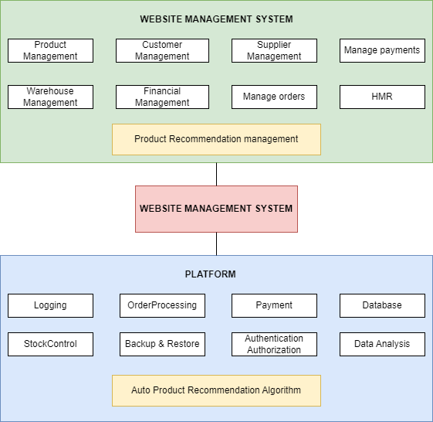

Figure 5‑1. Context Diagram

#### 5.1.2. Use Case Diagram

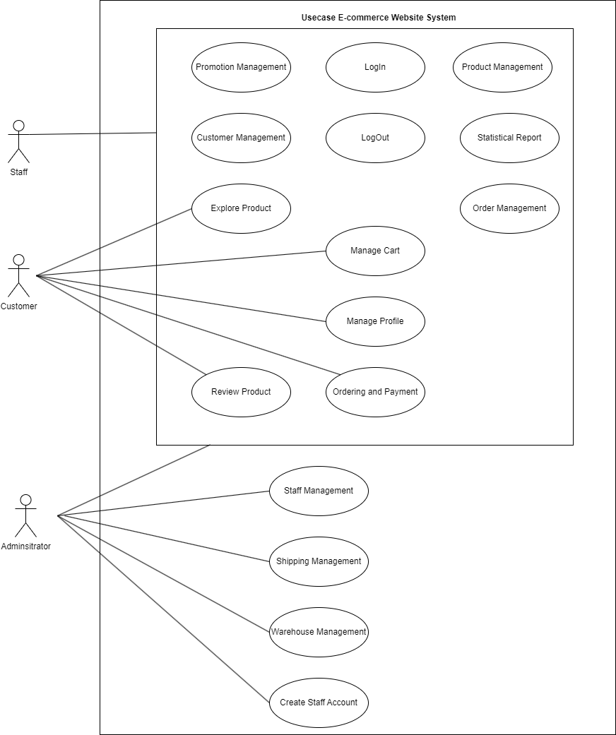

Figure 5‑2. Use case diagram

|  |  |
| --- | --- |
| Name | Customer Login |
| Scenario | LogIn |
| Description | The user logs into the system using username and password. |
| Actor | Customer |
| Trigger | The user opens the login page. |
| Related use cases | LogOut |
| Pre-condition | The user already has an account in the system. |
| Post-condition | The user is redirected to the main page. |
| Flow of events | 1. User opens the login page.  2. User enters login name and password.  3. The system checks login information.  4. Authentication and page transfer system |
| Exception conditions | Login information is incorrect. |

Table 5‑1. Detailed Specification Table Customer Login

Detailed Specification Table Customer Login

|  |  |
| --- | --- |
| Name | Customer LogOut |
| Scenario | LogOut |
| Description | The user logs out of the system. |
| Actor | Customer |
| Trigger | User selects logout function. |
| Related use cases | LogIn |
| Pre-condition | The user has logged into the system. |
| Post-condition | The user is redirected to the login page. |
| Flow of events | 1. User selects logout function.  2. The system ends the session.  3. The system redirects the user to the login page. |
| Exception conditions | User is not logged in. |

Table 5‑2. Detailed Specification Table Customer LogOut

Detailed Specification Table Customer LogOut

|  |  |
| --- | --- |
| Name | Customer Explore Product |
| Scenario | Explore Product |
| Description | Customers view the list of products available on the website. |
| Actor | Customer |
| Trigger | The user opens the product list page. |
| Related use cases | Manage Cart, Ordering and Payment |
| Pre-condition | None. |
| Post-condition | Customers can view product details or add to cart. |
| Flow of events | 1. Customer opens the product list page.  2. The system displays the product list.  3. Customers select products to view details or add to cart. |
| Exception conditions | No product found in the system. |

Table 5‑3. Detailed Specification Table Customer Explore Product

Detailed Specification Table Customer Explore Product

|  |  |
| --- | --- |
| Name | Customer Manage Cart |
| Scenario | Manage Cart |
| Description | Customers manage their shopping cart. |
| Actor | Customer |
| Trigger | User opens shopping cart. |
| Related use cases | Explore Product, Ordering and Payment |
| Pre-condition | The customer is logged in. |
| Post-condition | The customer's shopping cart is updated. |
| Flow of events | 1. Customer opens shopping cart.  2. Customer adds product to cart  3. The customer deletes the product from the cart.  4. Customer updates product quantity. |
| Exception conditions | Shopping cart is empty or the product is no longer in stock. |

Table 5‑4. Detailed Specification Table Customer Manage Cart

Detailed Specification Table Customer Manage Cart

|  |  |
| --- | --- |
| Name | Customer Manage Profile |
| Scenario | Manage Profile |
| Description | Customers manage personal information. |
| Actor | Customer |
| Trigger | User opens personal information page. |
| Related use cases | None |
| Pre-condition | The customer is logged in. |
| Post-condition | Customer's personal information is updated. |
| Flow of events | 1. Customer opens personal information page.  2. Customers update personal information.  3. The system saves updated information. |
| Exception conditions | System error when updating information. |

Table 5‑5. Detailed Specification Table Customer Manage Profile

Detailed Specification Table Customer Manage Profile

|  |  |
| --- | --- |
| Name | Customer Review Product |
| Scenario | Review Product |
| Description | Customers leave reviews for purchased products. |
| Actor | Customer |
| Trigger | The user opens the product details page. |
| Related use cases | None. |
| Pre-condition | The customer has purchased the product. |
| Post-condition | Customer reviews are stored and displayed. |
| Flow of events | 1. The customer opens the product details page.  2. Customers leave product reviews and ratings  3. The system saves the rating and displays it. |
| Exception conditions | You cannot leave a review if you have not purchased the product. |

Table 5‑6. Detailed Specification Table Customer Review Product

Detailed Specification Table Customer Review Product

|  |  |
| --- | --- |
| Name | Customer Ordering and Payment |
| Scenario | Ordering and Payment |
| Description | Customers make orders and payments. |
| Actor | Customer |
| Trigger | User selects payment from cart. |
| Related use cases | Manage Cart, Explore Product |
| Pre-condition | The customer is logged in and has products in the cart. |
| Post-condition | The customer's order was successfully stored and paid. |
| Flow of events | 1. Customer opens shopping cart and selects payment.  2. Customer enters payment information.  3. Payment processing system.  4. The system confirms the order and sends a notification. |
| Exception conditions | Payment failed or system error. |

Table 5‑7. Detailed Specification Table Customer Ordering and Payment

Detailed Specification Table Customer Ordering and Payment

|  |  |
| --- | --- |
| Name | Administrator LogIn |
| Scenario | LogIn |
| Description | Admin logs into the system with username and password. |
| Actor | Administrator |
| Trigger | Admin opens the login page. |
| Related use cases | LogOut |
| Pre-condition | Admin already has an account in the system. |
| Post-condition | Admin is redirected to the main page. |
| Flow of events | 1. Admin opens the login page.  2. Admin enters username and password.  3. The system checks login information.  4. Authentication and page transfer system. |
| Exception conditions | Login information is incorrect. |

Table 5‑8. Detailed Specification Table Administrator LogIn

Detailed Specification Table Administrator LogIn

|  |  |
| --- | --- |
| Name | Administrator LogOut |
| Scenario | LogOut |
| Description | Admin logs out of the system. |
| Actor | Administrator |
| Trigger | Admin selects the logout function. |
| Related use cases | LogIn |
| Pre-condition | Admin has logged into the system. |
| Post-condition | Admin is redirected to the login page. |
| Flow of events | 1. Admin selects the logout function.  2. The system ends the session.  3. The system redirects Admin to the login page. |
| Exception conditions | Admin is not logged in. |

Table 5‑9. Detailed Specification Table Administrator LogOut

Detailed Specification Table Administrator LogOut

|  |  |
| --- | --- |
| Name | Administrator Staff Management |
| Scenario | Staff Management |
| Description | Admin manages employee information. |
| Actor | Administrator |
| Trigger | Admin opens the employee management page. |
| Related use cases | Create Staff Account |
| Pre-condition | Admin is logged in. |
| Post-condition | Employee information is added, deleted, or updated. |
| Flow of events | 1. Admin opens the employee management page.  2. Admin adds, deletes or updates employee information.  3. The system stores employee information. |
| Exception conditions | Employee information is incorrect or duplicated. |

Table 5‑10. Detailed Specification Table Administrator Staff Management

Detailed Specification Table Administrator Staff Management

|  |  |
| --- | --- |
| Name | Administrator Shipping Management |
| Scenario | Shipping Management |
| Description | Admin manages shipping information. |
| Actor | Administrator |
| Trigger | Admin opens the shipping management page. |
| Related use cases | None |
| Pre-condition | Admin is logged in. |
| Post-condition | Shipping information is added, deleted, or updated. |
| Flow of events | 1. Admin opens the shipping management page.  2. Admin adds, deletes or updates shipping information.  3. The system stores shipping information. |
| Exception conditions | Shipping information is incorrect. |

Table 5‑11. Detailed Specification Table Administrator Shipping Management

Detailed Specification Table Administrator Shipping Management

|  |  |
| --- | --- |
| Name | Administrator Warehouse Management |
| Scenario | Warehouse Management |
| Description | Admin manages the warehouse. |
| Actor | Administrator |
| Trigger | Admin opens the warehouse management page. |
| Related use cases | None |
| Pre-condition | Admin is logged in. |
| Post-condition | Inventory information is added, deleted, or updated. |
| Flow of events | 1. Admin opens the warehouse management page.  2. Admin adds, deletes or updates warehouse information.  3. The system stores warehouse information. |
| Exception conditions | Inventory information is incorrect. |

Table 5‑12. Detailed Specification Table Administrator Warehouse Management

|  |  |
| --- | --- |
| Name | Administrator Create Staff Account |
| Scenario | Create Staff Account |
| Description | Admin creates accounts for new employees. |
| Actor | Administrator |
| Trigger | Admin opens the employee account creation page. |
| Related use cases | Staff Management |
| Pre-condition | Admin is logged in. |
| Post-condition | New employee account created successfully. |
| Flow of events | 1. Admin opens the employee account creation page.  2. Admin enters new employee information.  3. The system creates an account and notifies you successfully. |
| Exception conditions | Employee information is duplicated or incorrect. |

Table 5‑13. Detailed Specification Table Administrator Create Staff Account

|  |  |
| --- | --- |
| Name | Staff LogIn |
| Scenario | LogIn |
| Description | Staff logs into the system with username and password. |
| Actor | Staff |
| Trigger | Staff opens the login page. |
| Related use cases | LogOut |
| Pre-condition | Staff already has an account in the system. |
| Post-condition | Staff is redirected to the main page. |
| Flow of events | 1. Staff opens the login page.  2. Staff enters username and password.  3. The system checks login information.  4. Authentication and page transfer system. |
| Exception conditions | Login information is incorrect. |

Table 5‑14. Detailed Specification Table Staff LogIn

|  |  |
| --- | --- |
| Name | Staff LogOut |
| Scenario | LogOut |
| Description | Staff logs out of the system. |
| Actor | Staff |
| Trigger | Staff selects the logout function. |
| Related use cases | LogIn |
| Pre-condition | Staff has logged into the system. |
| Post-condition | Staff is redirected to the login page. |
| Flow of events | 1. Staff chooses the logout function.  2. The system ends the session.  3. The system transfers Staff to the login page. |
| Exception conditions | Staff is not logged in. |

Table 5‑15. Detailed Specification Table Staff LogOut

|  |  |
| --- | --- |
| Name | Staff Promotion Management |
| Scenario | Promotion Management |
| Description | Staff manages promotions on the website. |
| Actor | Staff |
| Trigger | Staff opens the promotion management page. |
| Related use cases | None |
| Pre-condition | Staff is logged in. |
| Post-condition | Promotion is added, removed or updated. |
| Flow of events | 1. Staff opens the promotion management page.  2. Staff add, delete or update promotions  3. The system stores promotion information. |
| Exception conditions | Promotion information is incorrect. |

Table 5‑16. Detailed Specification Table Staff Promotion Management

|  |  |
| --- | --- |
| Name | Staff Product Management |
| Scenario | Product Management |
| Description | Staff manages products on the website. |
| Actor | Staff |
| Trigger | Staff opens the product management page. |
| Related use cases | None |
| Pre-condition | Staff is logged in. |
| Post-condition | Product is added, removed or updated. |
| Flow of events | 1. Staff opens the product management page.  2. Staff add, delete or update products.  3. The system stores product information. |
| Exception conditions | Product information is incorrect or duplicated. |

Table 5‑17. Detailed Specification Table Staff Product Management

|  |  |
| --- | --- |
| Name | Staff Customer Management |
| Scenario | Customer Management |
| Description | Staff manages customer information. |
| Actor | Staff |
| Trigger | Staff opens the customer management page. |
| Related use cases | None |
| Pre-condition | Staff is logged in. |
| Post-condition | Customer information is added, deleted, or updated. |
| Flow of events | 1. Staff opens the customer management page.  2. Staff adds, deletes or updates customer information.  3. The system stores customer information. |
| Exception conditions | Customer information is incorrect. |

Table 5‑18. Detailed Specification Table Staff Customer Management

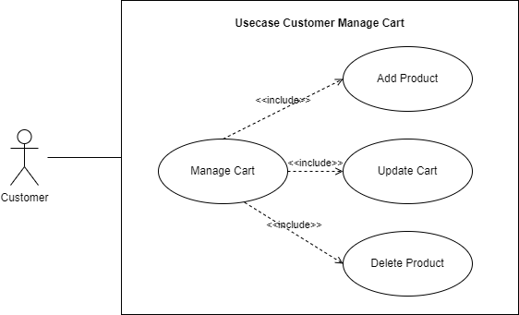

Figure 5‑3. Usecase Diagram Customer Manage Cart

|  |  |
| --- | --- |
| Name | Customer Manage Cart |
| Scenario | Manage Cart |
| Description | Manage customers' shopping carts, including adding products, updating carts, and deleting products. |
| Actor | Customer |
| Trigger | Customer opens shopping cart |
| Related use cases | Add Product, Update Cart, Delete Product |
| Pre-condition | The customer is logged in. |
| Post-condition | The customer's shopping cart is updated. |
| Flow of events | 1. Customer opens shopping cart.  2. The system displays the customer's shopping cart.  3. Customers can add products, update quantities or remove products from the cart. |
| Exception conditions | Shopping cart is empty or the product is no longer in stock. |

Table 5‑19. Detailed Specification Table Customer Manage Cart

|  |  |
| --- | --- |
| Name | Customer Add Product |
| Scenario | Add Product |
| Description | Customer adds product to cart. |
| Actor | Customer |
| Trigger | Customer selects product and adds to cart |
| Related use cases | Manage Cart |
| Pre-condition | The customer is logged in and is viewing product details. |
| Post-condition | The product is added to the customer's cart. |
| Flow of events | 1. Customers choose the product to buy.  2. Customer selects "Add to Cart".  3. Inventory checking system.  4. The system adds products to the cart and updates the quantity. |
| Exception conditions | The product is no longer in stock or the customer is not logged in. |

Table 5‑20. Detailed Specification Table Customer Add Product

|  |  |
| --- | --- |
| Name | Customer Update Cart |
| Scenario | Update Cart |
| Description | The customer updates the number of products in the cart.  Actor Customer |
| Actor | Customer |
| Trigger | Customer opens shopping cart |
| Related use cases | Manage Cart |
| Pre-condition | The customer is logged in and has products in the cart. |
| Post-condition | The number of products in the cart is updated. |
| Flow of events | 1. Customer opens shopping cart.  2. Customer changes product quantity.  3. Inventory checking system.  4. The system updates the number of products in the shopping cart. |
| Exception conditions | The product is no longer in stock or the customer is not logged in. |

Table 5‑21. Detailed Specification Table Customer Update Cart

|  |  |
| --- | --- |
| Name | Customer Delete Product |
| Scenario | Delete Product |
| Description | The customer deletes the product from the cart. |
| Actor | Customer |
| Trigger | Customer opens shopping cart |
| Related use cases | Manage Cart |
| Pre-condition | The customer is logged in and has products in the cart. |
| Post-condition | The product is removed from the customer's cart. |
| Flow of events | 1. Customer opens shopping cart.  2. The customer selects the product to delete.  3. Customer selects "Remove".  4. The system deletes products from the shopping cart and updates the shopping cart. |
| Exception conditions | The customer is not logged in or the cart does not have products to delete. |

Table 5‑22. Detailed Specification Table Customer Delete Product

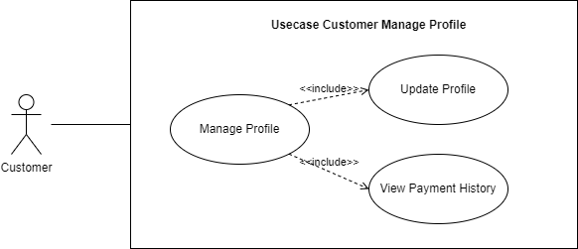

Figure 5‑4. Usecase Diagram Customer Manage Profile

|  |  |
| --- | --- |
| Name | Customer Manage Profile |
| Scenario | Manage Profile |
| Description | Manage customer personal profiles, including updating information and viewing payment history. |
| Actor | Customer |
| Trigger | The customer opens the profile management page. |
| Related use cases | Update Profile, View Payment History |
| Pre-condition | The customer is logged in. |
| Post-condition | The customer's profile is updated or the customer views payment history. |
| Flow of events | 1. Customer opens profile management page.  2. The system displays profile information and options such as updating profile and viewing payment history.  3. Customers choose to update or view payment history. |
| Exception conditions | Record inaccessible or update failed. |

Table 5‑23. Detailed Specification Table Customer Manage Profile

|  |  |
| --- | --- |
| Name | Customer Update Profile |
| Scenario | Update Profile |
| Description | Customers update their personal information. |
| Actor | Customer |
| Trigger | Customer chooses to update information from the profile management page. |
| Related use cases | Manage Profile |
| Pre-condition | The customer has logged in and opened the profile management page. |
| Post-condition | The customer's personal information has been successfully updated. |
| Flow of events | 1. Customers choose to update personal information.  2. Customers enter new information into the data fields that need to be changed.  3. The system checks and saves new information.  4. The system confirms the update was successful. |
| Exception conditions | Inaccurate information or system error when storing. |

Table 5‑24. Detailed Specification Table Customer Update Profile

|  |  |
| --- | --- |
| Name | Customer View Payment History |
| Scenario | View Payment History |
| Description | Customers view their payment history. |
| Actor | Customer |
| Trigger | Customer chooses to view payment history from the profile management page. |
| Related use cases | Manage Profile |
| Pre-condition | The customer has logged in and opened the profile management page. |
| Post-condition | Customers can view their payment history. |
| Flow of events | 1. Customers choose to view payment history.  2. The system retrieves customer payment history data.  3. The system displays payment history to customers. |
| Exception conditions | No payment history or system error when retrieving data. |

Table 5‑25. Detailed Specification Table Customer View Payment History

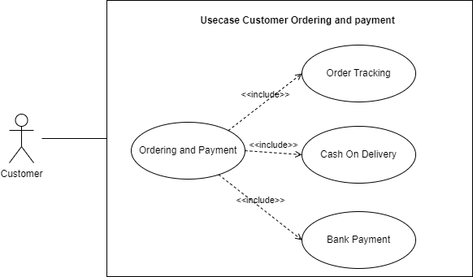

Figure 5‑5. Usecase Diagram Customer Ordering and payment

|  |  |
| --- | --- |
| Name | Customer Ordering and Payment |
| Scenario | Ordering and Payment |
| Description | Customers place orders and pay, including order tracking, payment on delivery and bank payments. |
| Actor | Customer |
| Trigger | Customer chooses to order and pay. |
| Related use cases | Order Tracking, Cash on Delivery, Bank Payment |
| Pre-condition | The customer has logged in and selected a product to buy. |
| Post-condition | The order was placed and paid successfully |
| Flow of events | 1. Customer selects product and adds to cart.  2. Customers place an order and make payment.  3. Customer chooses payment method.  4. Order processing and payment system. |
| Exception conditions | Error during payment or product unavailable. |

Table 5‑26. Detailed Specification Table Customer Ordering and Payment

|  |  |
| --- | --- |
| Name | Customer Order Tracking |
| Scenario | Order Tracking |
| Description | Customers track the status of their orders. |
| Actor | Customer |
| Trigger | The customer opens the order tracking page. |
| Related use cases | Ordering and Payment |
| Pre-condition | The customer is logged in and has placed an order. |
| Post-condition | Customers know the status of their orders. |
| Flow of events | 1. Customer opens the order tracking page.  2. The system retrieves customer order information.  3. The system displays order status. |
| Exception conditions | Error when retrieving order information or the order does not exist. |

Table 5‑27. Detailed Specification Table Customer Order Tracking

|  |  |
| --- | --- |
| Name | Customer Cash on Delivery |
| Scenario | Cash on Delivery |
| Description | Customers pay when receiving goods. |
| Actor | Customer |
| Trigger | Customer chooses to pay upon receipt of goods. |
| Related use cases | Ordering and Payment |
| Pre-condition | The customer has logged in and confirmed the order. |
| Post-condition | Orders are confirmed and paid upon receipt. |
| Flow of events | 1. Customer selects "Cash on Delivery" when confirming order.  2. The system confirms the payment method.  3. The system stores order information with payment method upon receipt. |
| Exception conditions | Error when confirming order or payment. |

Table 5‑28. Detailed Specification Table Customer Cash on Delivery

|  |  |
| --- | --- |
| Name | Customer Bank Payment |
| Scenario | Bank Payment |
| Description | Customers pay via bank. |
| Actor | Customer |
| Trigger | Customer chooses to pay via bank. |
| Related use cases | Ordering and Payment |
| Pre-condition | The customer has logged in and confirmed the order. |
| Post-condition | Order is confirmed and paid via bank. |
| Flow of events | 1. Customer selects "Bank Payment" when confirming order.  2. The system redirects customers to the bank payment page.  3. Customer enters bank payment information.  4. The system confirms successful payment and saves order information. |
| Exception conditions | Error when confirming bank payment or incorrect payment information. |

Table 5‑29. Detailed Specification Table Customer Bank Payment

#### 5.1.3. Activity Diagram

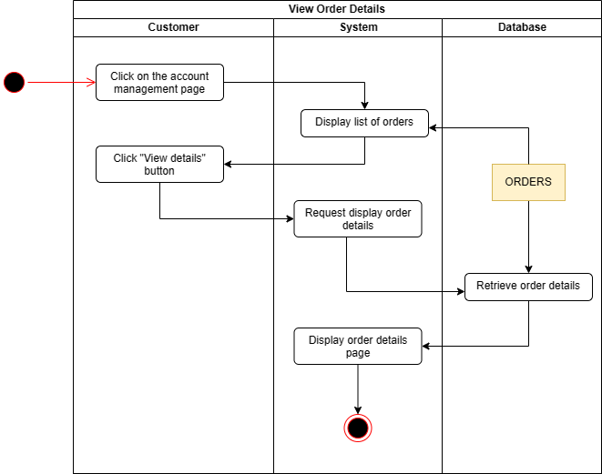

Figure 5‑6. Activity Diagram - View Order Details

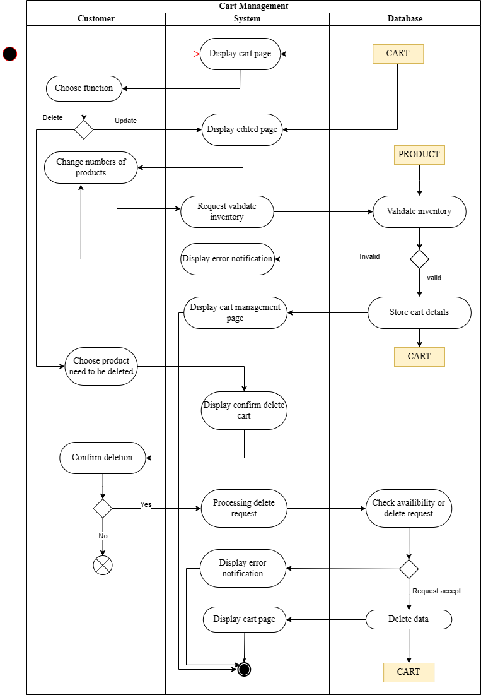

Figure 5‑7. Activity Diagram - Cart Management

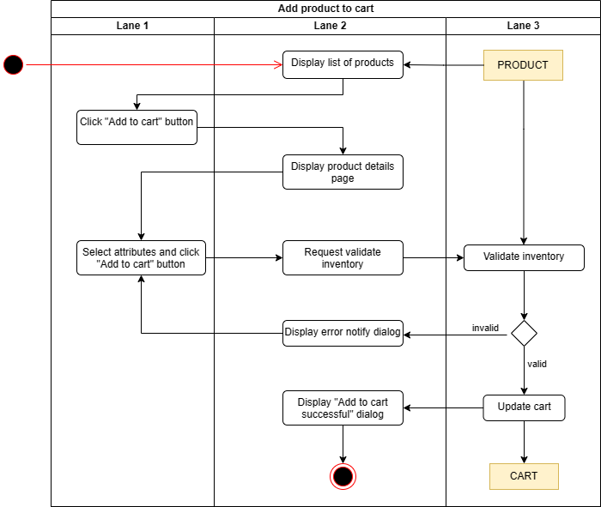

Figure 5‑8. Activity Diagram - Add Product to Cart

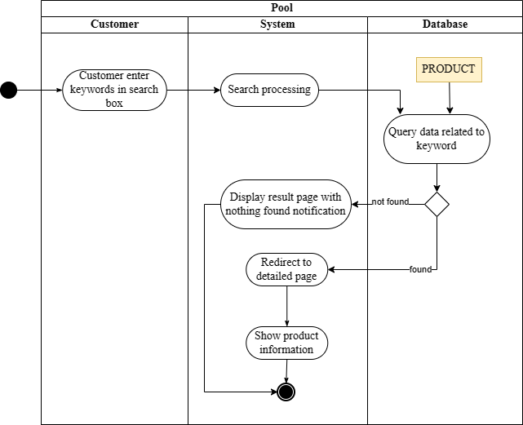

Figure 5‑9. Activity Diagram - Pool

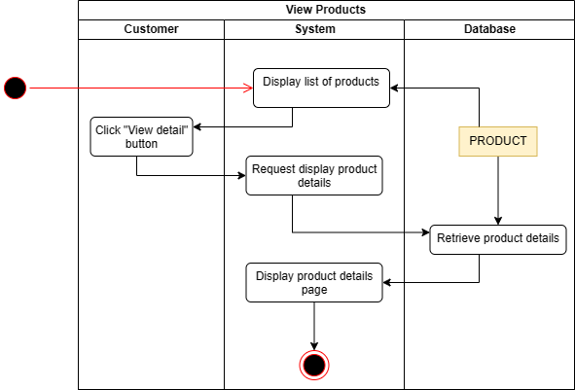

Figure 5‑10. Activity view product

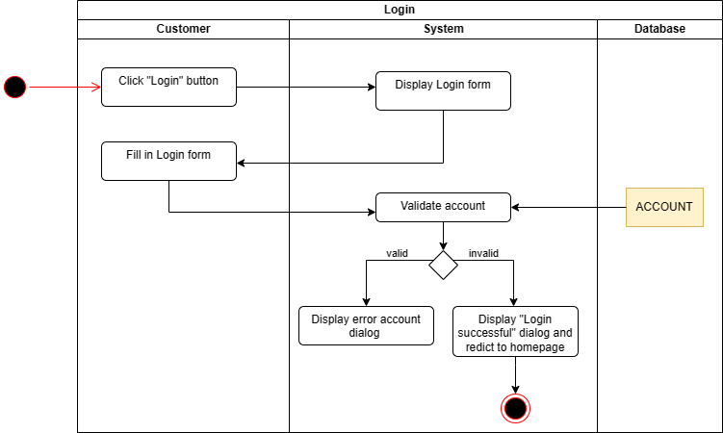

Figure 5‑11. Activity Diagram - Login

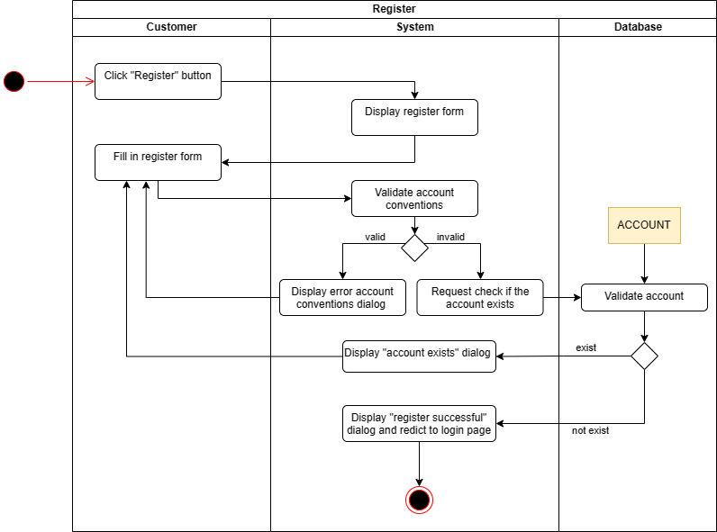

Figure 5‑12. Activity Diagram - Register

#### 5.1.4. Sequence Diagram

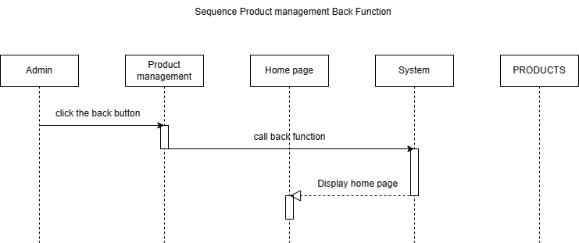

Figure 5‑13. Sequence Product management Back Function

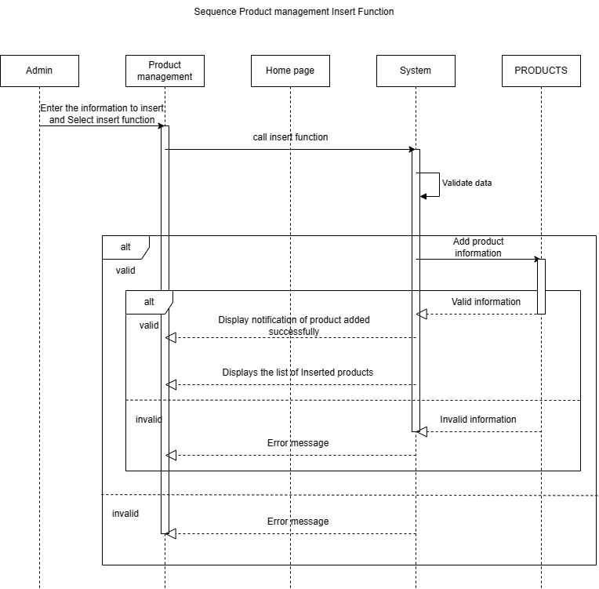

Figure 5‑14. Sequence Product management Insert Function

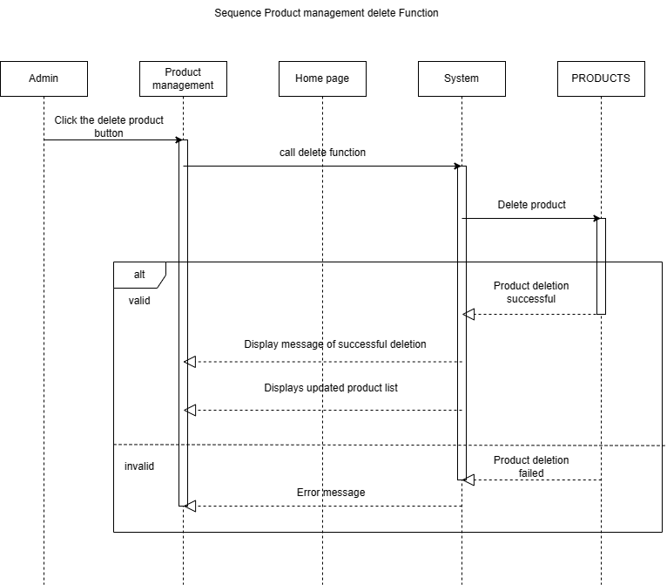

Figure 5‑15. Sequence Product management delete Function.

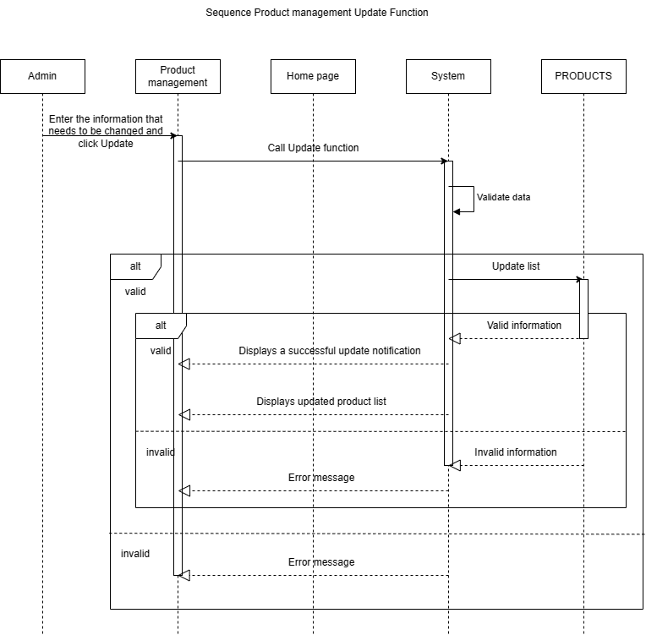

Figure 5‑16. Sequence Product management Update Function

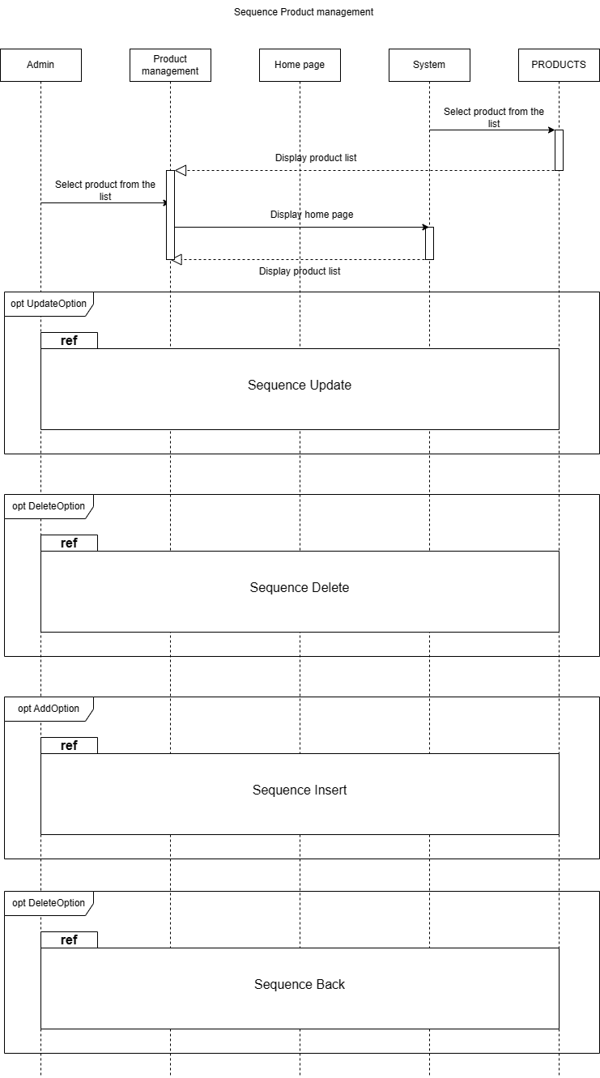

Figure 5‑17. Sequence product management.

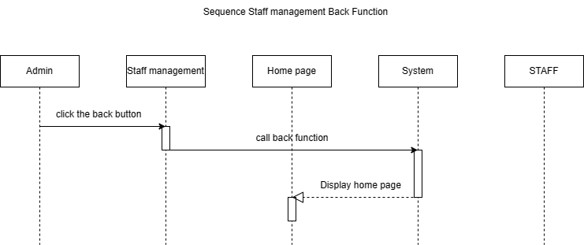

Figure 5‑18. Sequence Staff management Back Function

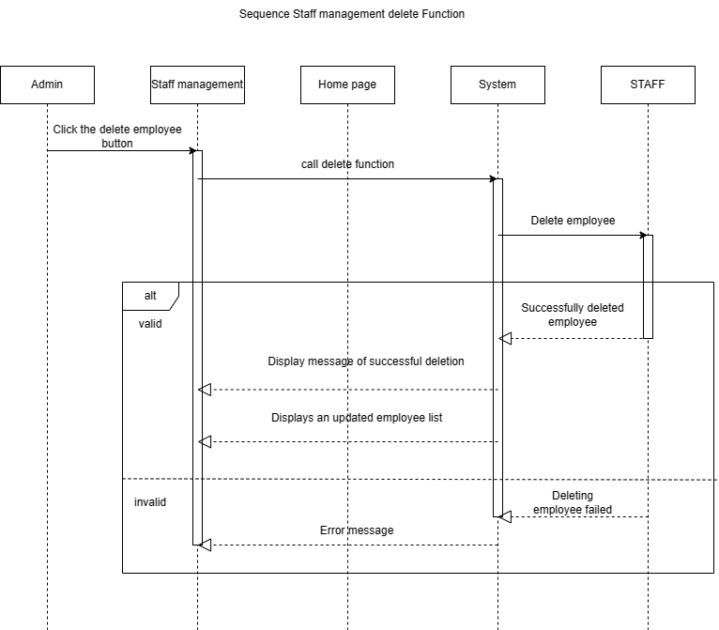

Figure 5‑19. Sequence Staff management delete function

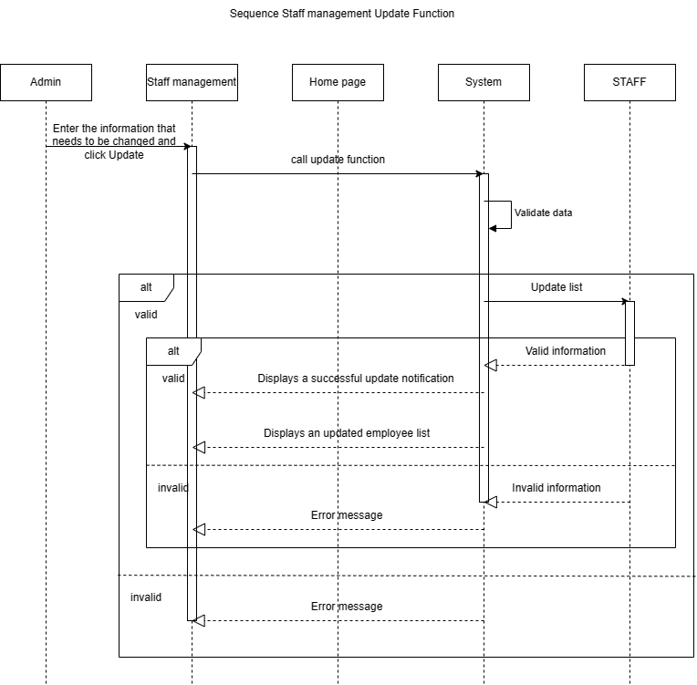

Figure 5‑20. Sequence Staff management Update function

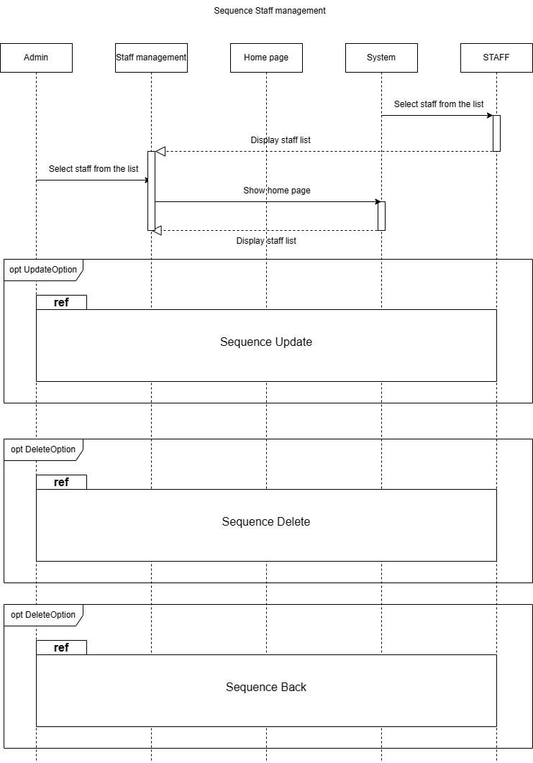

Figure 5‑21. Sequence Staff management.

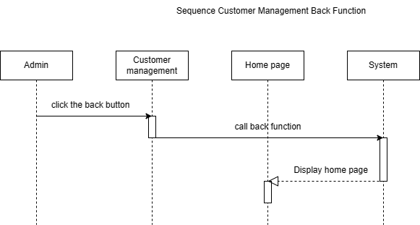

Figure 5‑22. Sequence Customer Management Back function

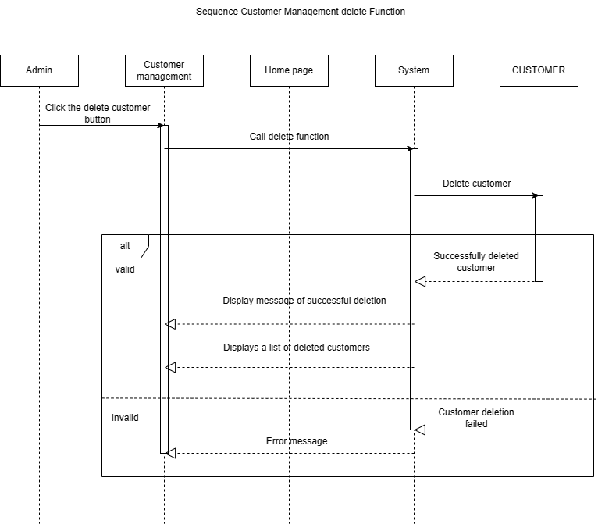

Figure 5‑23.Sequence Customer Management delete Function

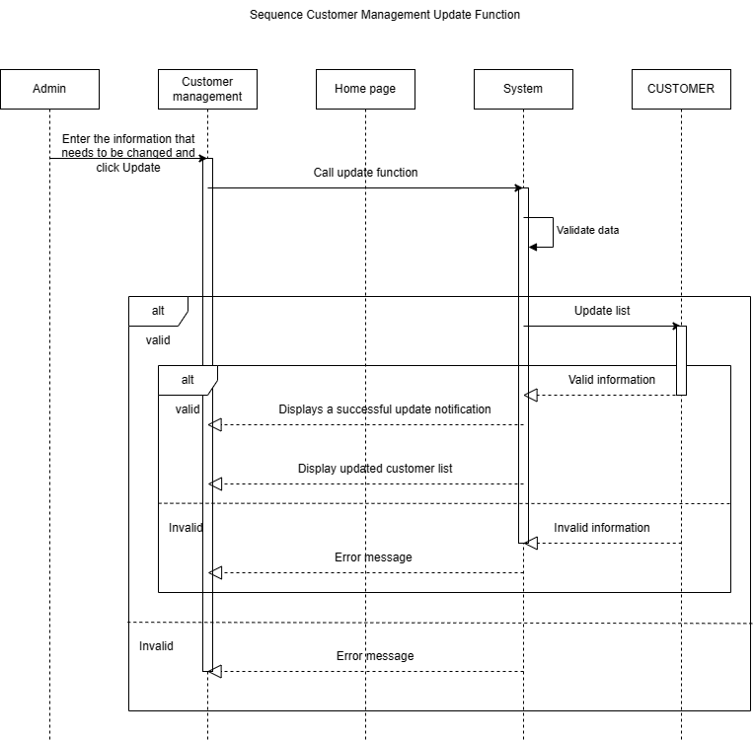

Figure 5‑24.Sequence Customer Management Update Function

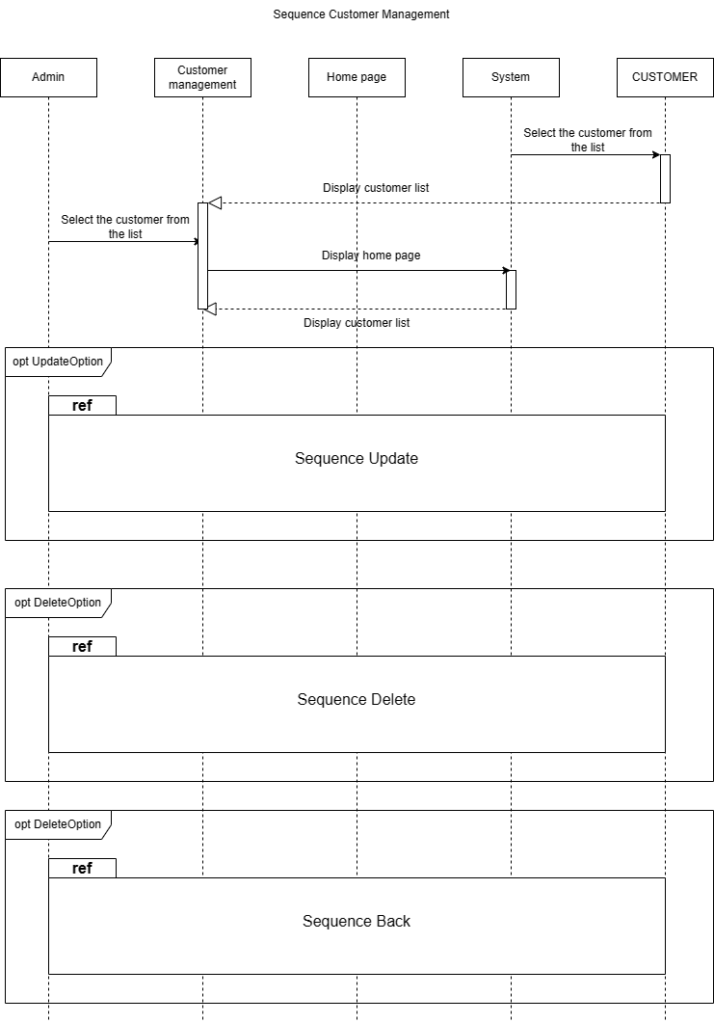

Figure 5‑25. Sequence Customer management

### Functional and non-functional requirements

## IMPLEMENTATION AND EXECUTION

### Deployment Description

### Core System Functionalities

### Integration of APIs, Web Crawlers, and Web Automation

### Evaluation of Achieved Results

## CONCLUSION AND DEVELOPMENT DIRECTIONS

### Summary of Achieved Results

### Limitations and Challenges

### Future Development Directions

# REFERENCES